|  |  |  |
| --- | --- | --- |
| SCHOOL OF INFORMATION TECHNOLOGY | | |
| NAME: Barroga, Shaira B. | |  |
| SECTION: IDC2 | DATE SUBMITTED: December 8 |

# SYSADM1 PORTFOLIO

**Table of Contents**

|  |  |  |
| --- | --- | --- |
| **Name of Activities** | **Date of Activity** | **Page No.** |
| **First Grading** | | |
| Evolution of Systems Administration: From Manual to Automated | August 14 | 3 |
| Creating File Systems | August 22 | 4 |
| Managing Services in Linux | September 12 | 8 |
| **Midterms** | | |
| Activity 1 | September 26 | 12 |
| Server | October 8 | 13 |
| Activity 2 | October 10 | 16 |
| **Finals** | | |
| Git | November 21 | 17 |
| Data Loss | November 21 | 20 |
| Capacity Management & Planning | November 28 | 23 |
| Course Reflection |  |  |

**First Grading**

**Evolution of Systems Administration: From Manual to Automated**

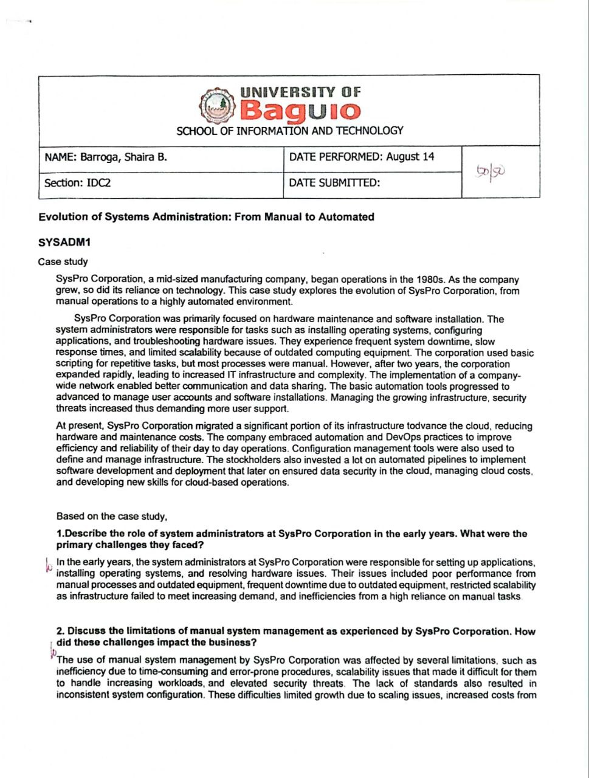

**Creating File Systems**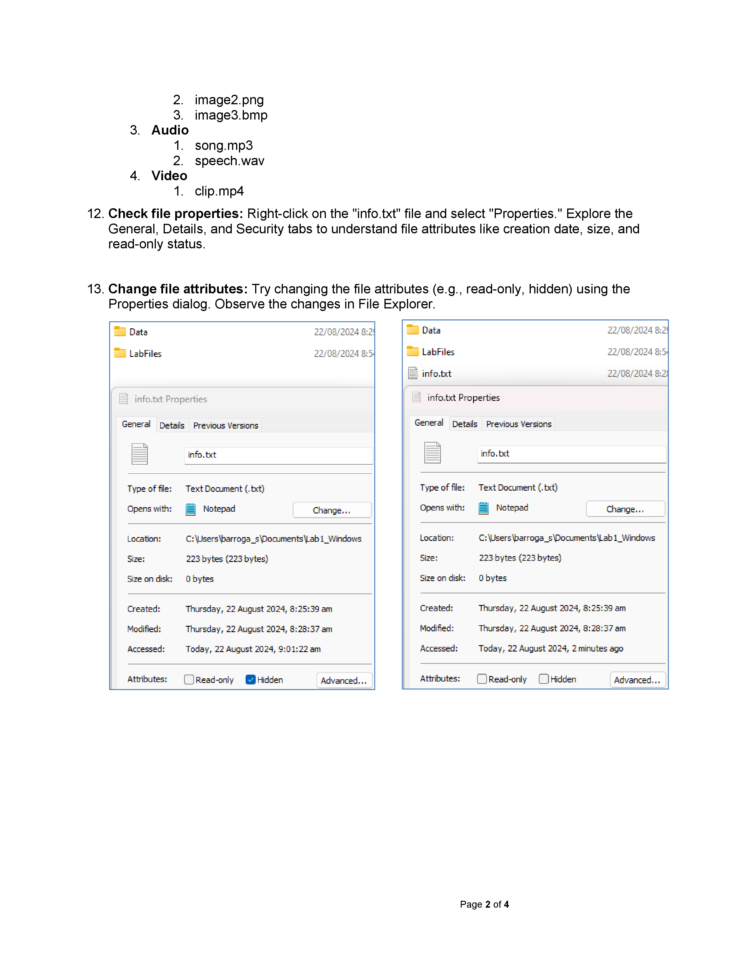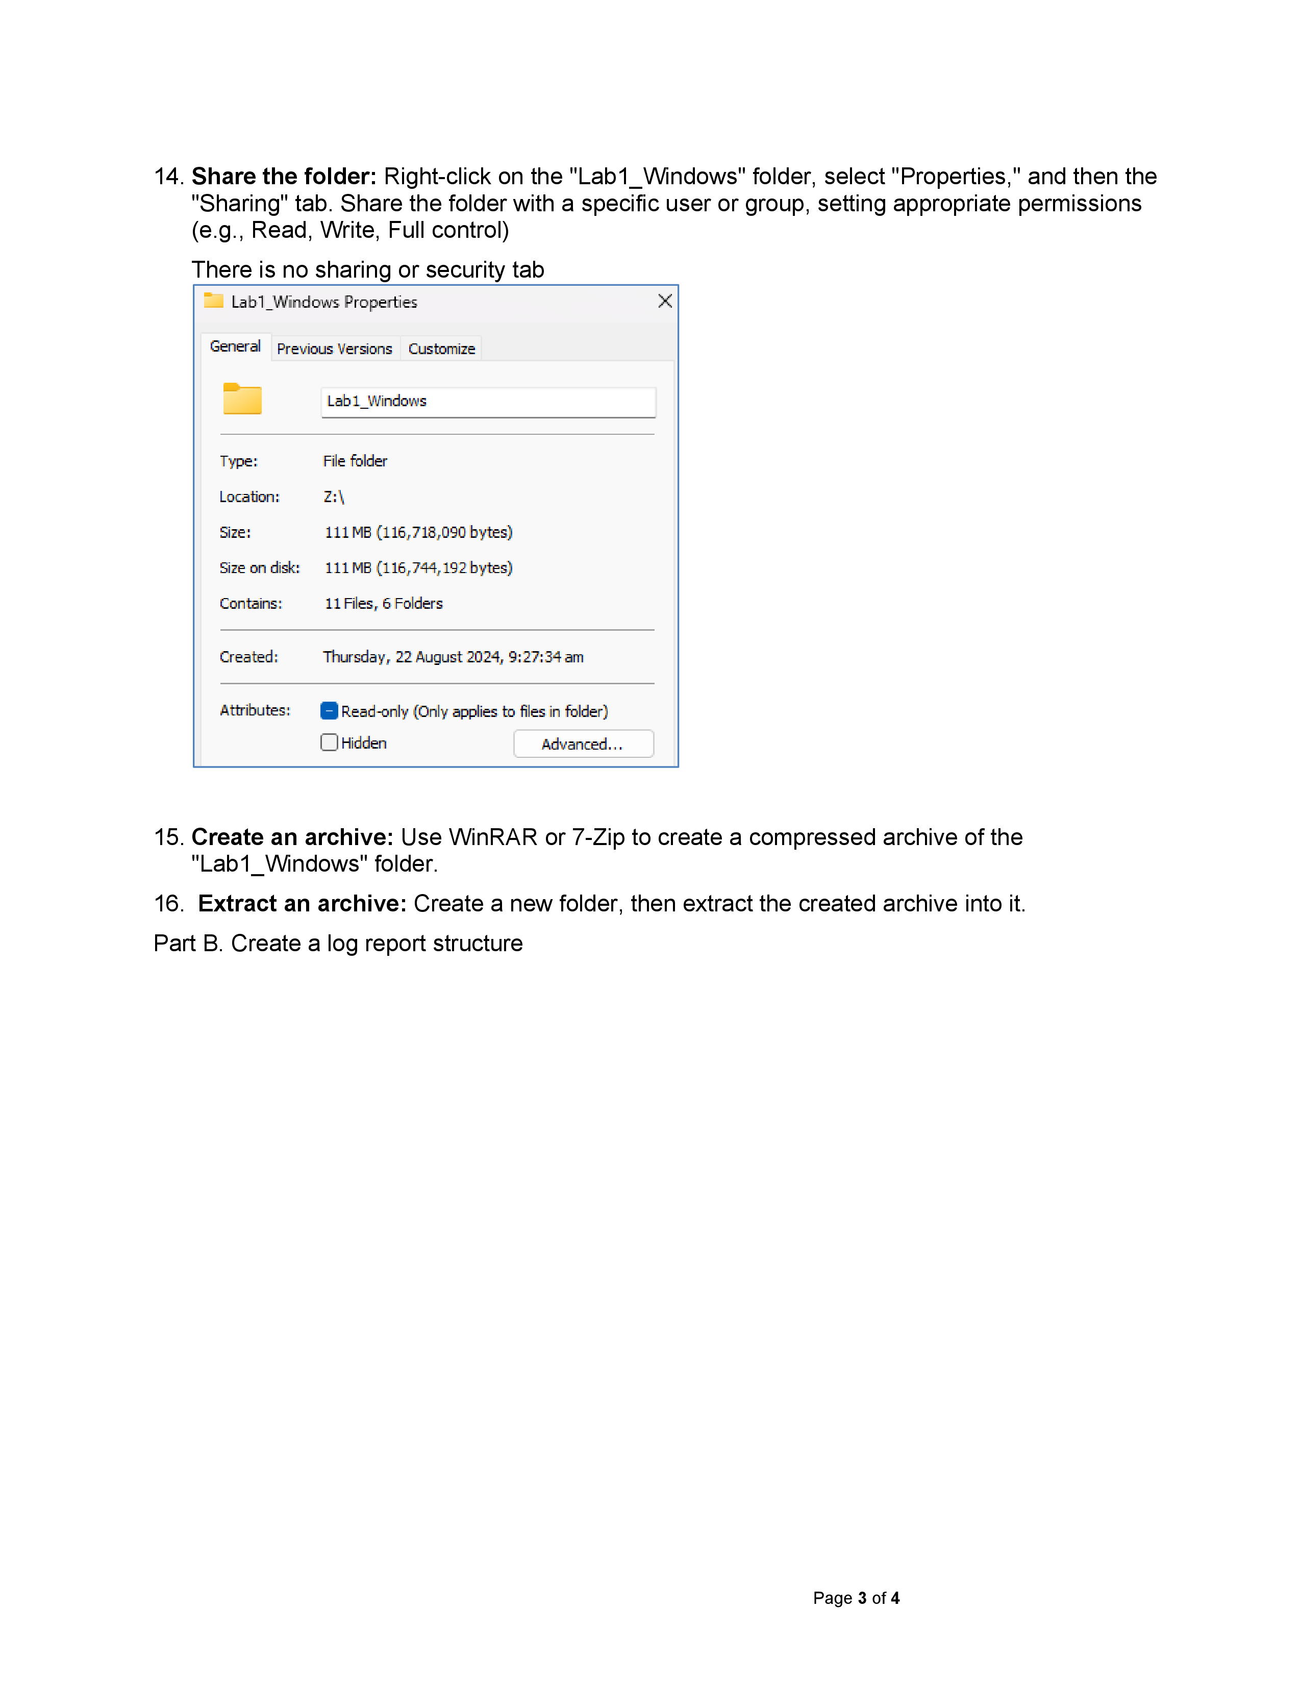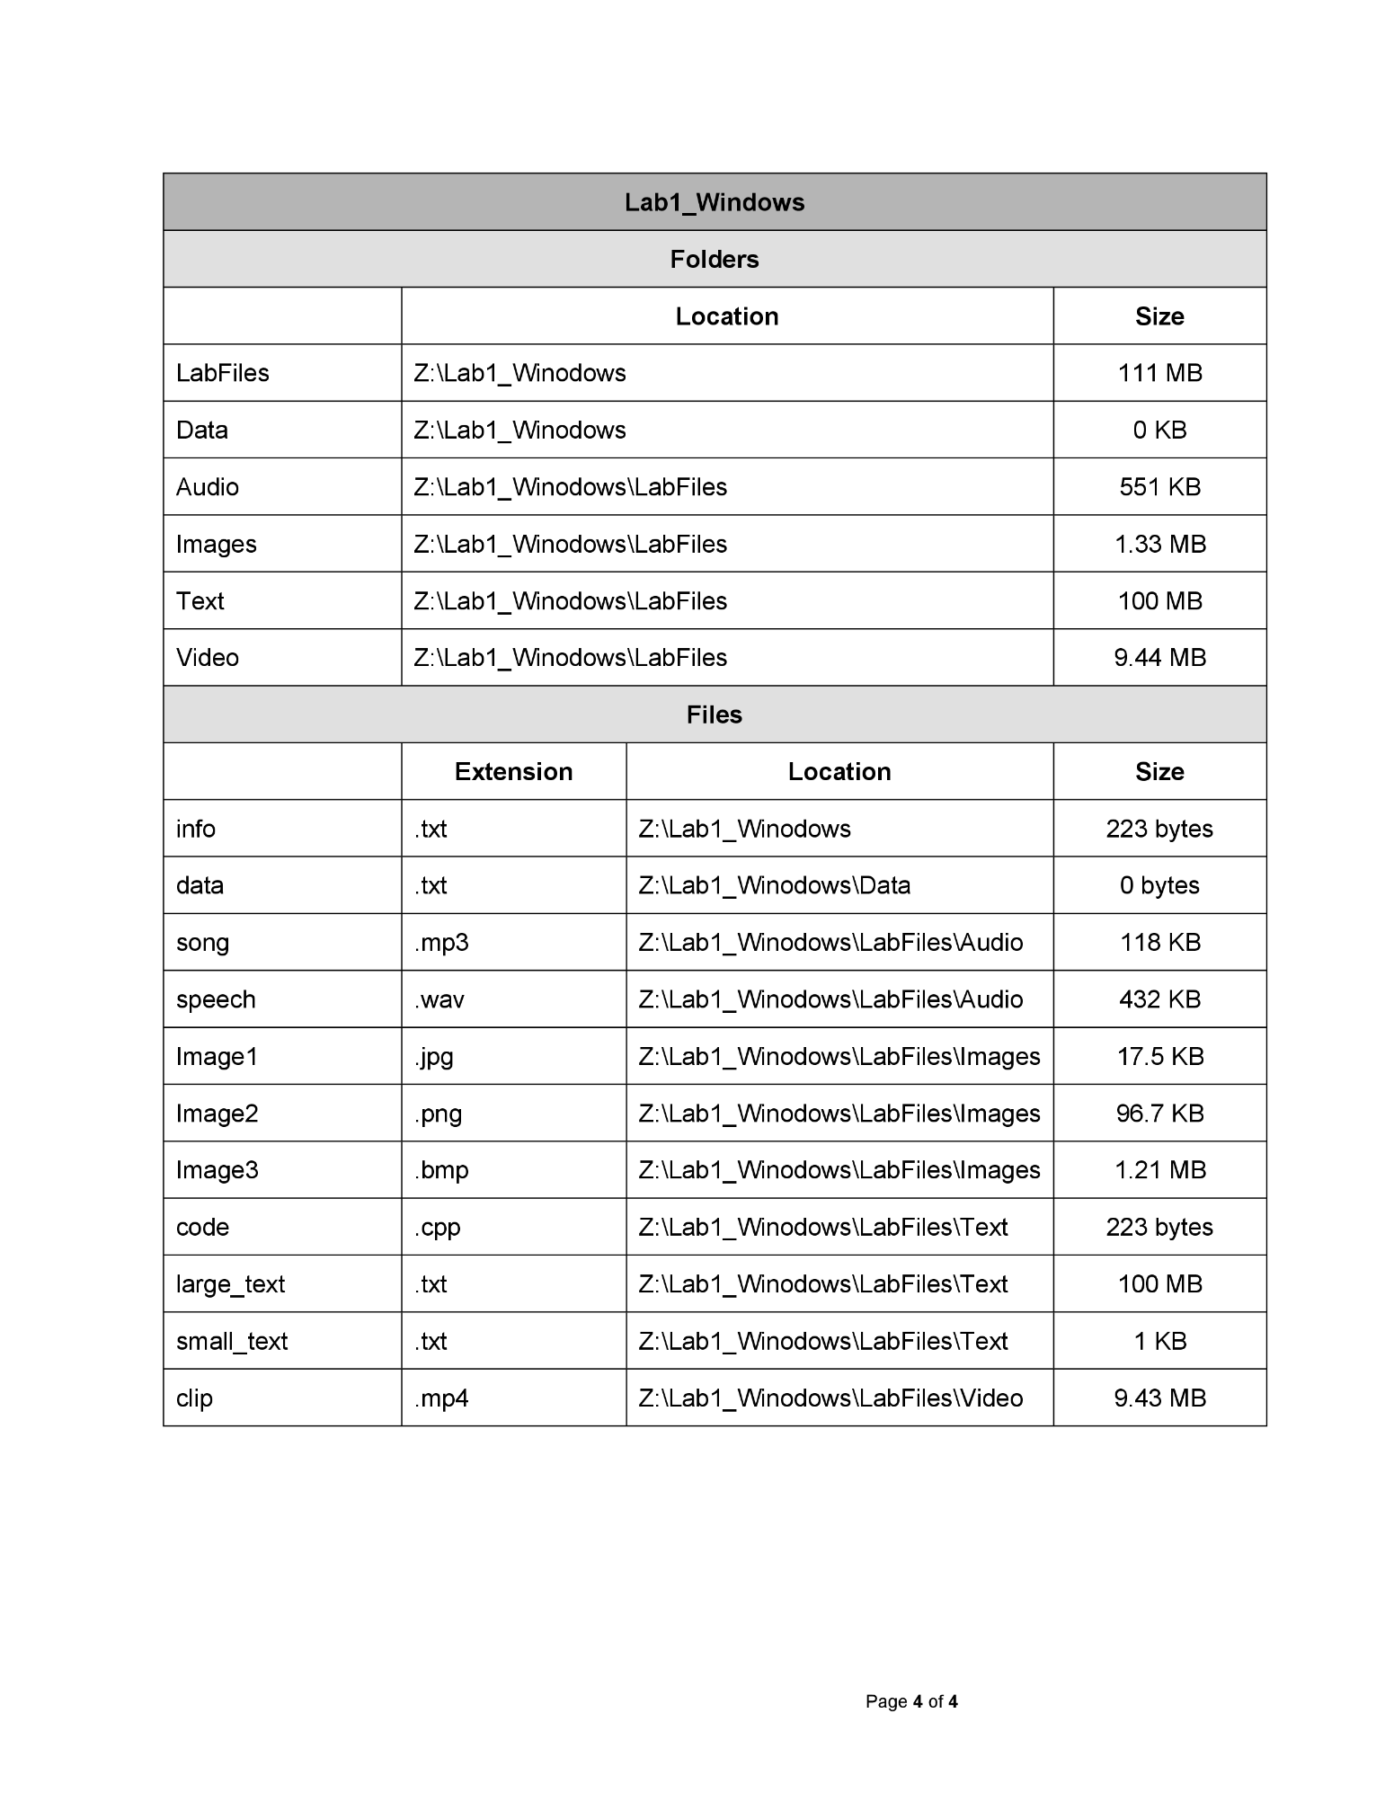

**Managing Services in Linux**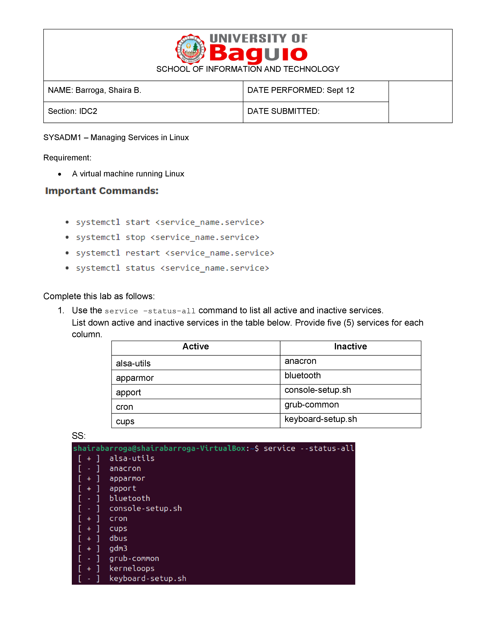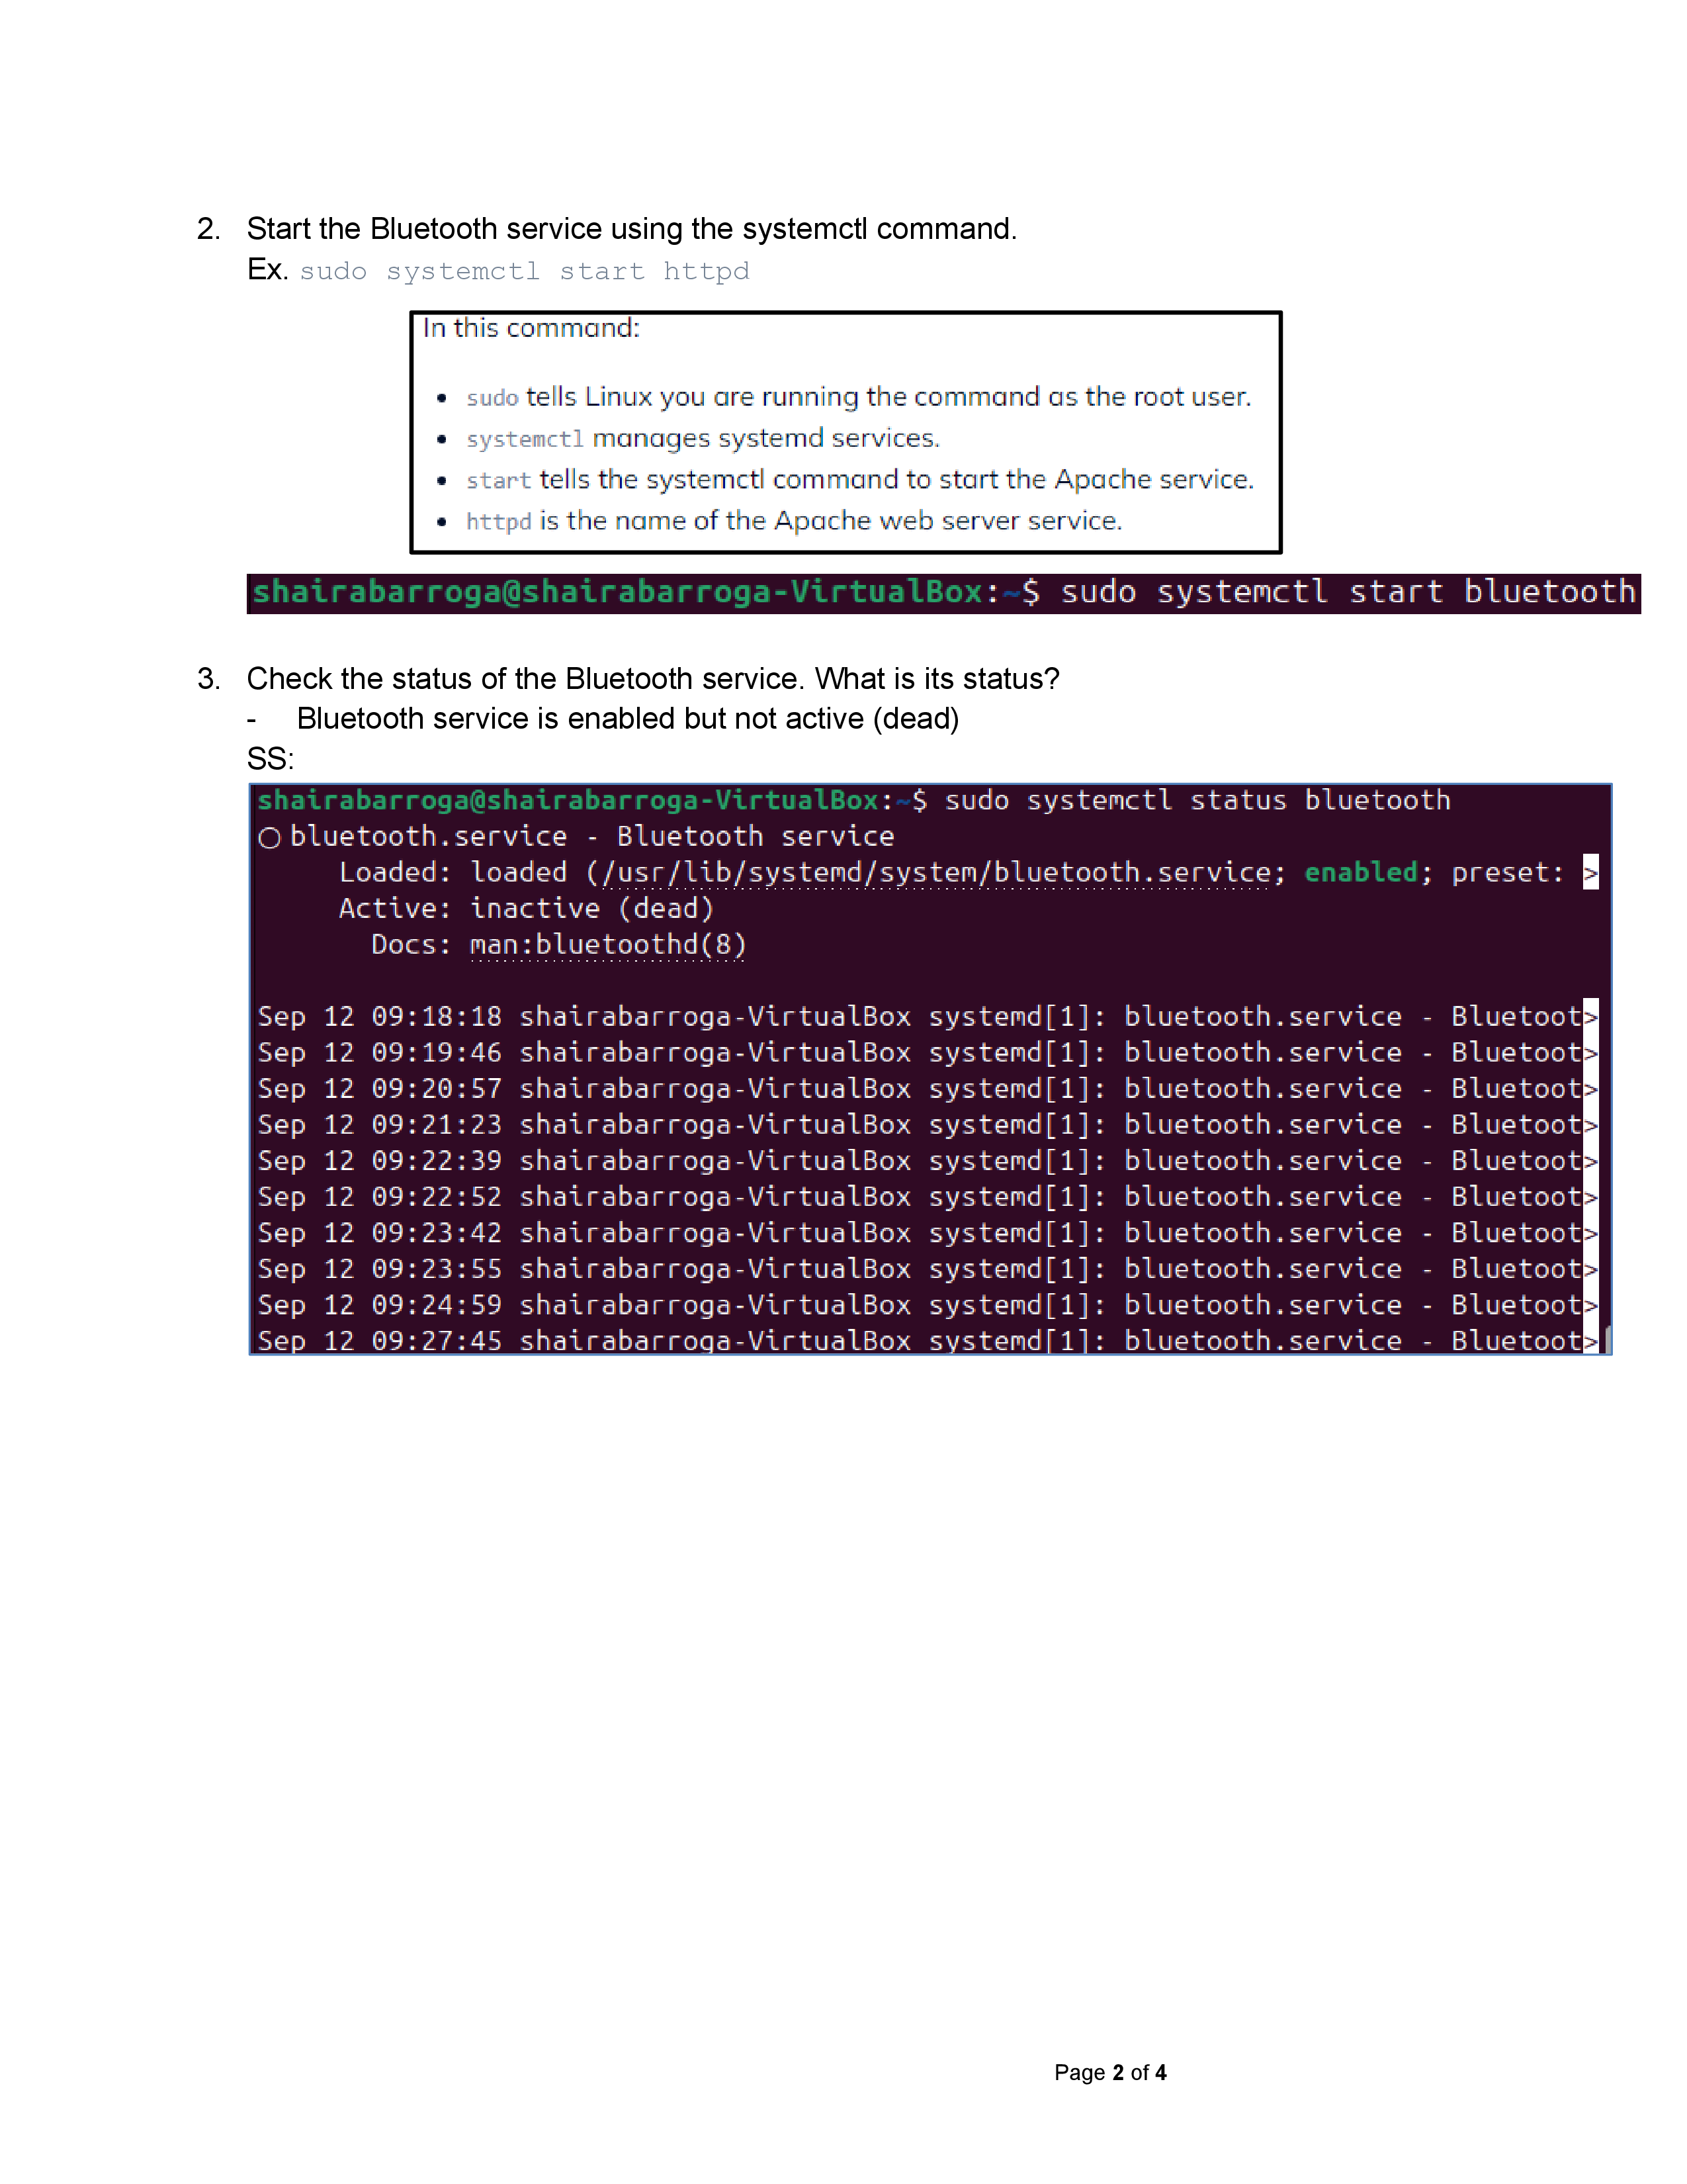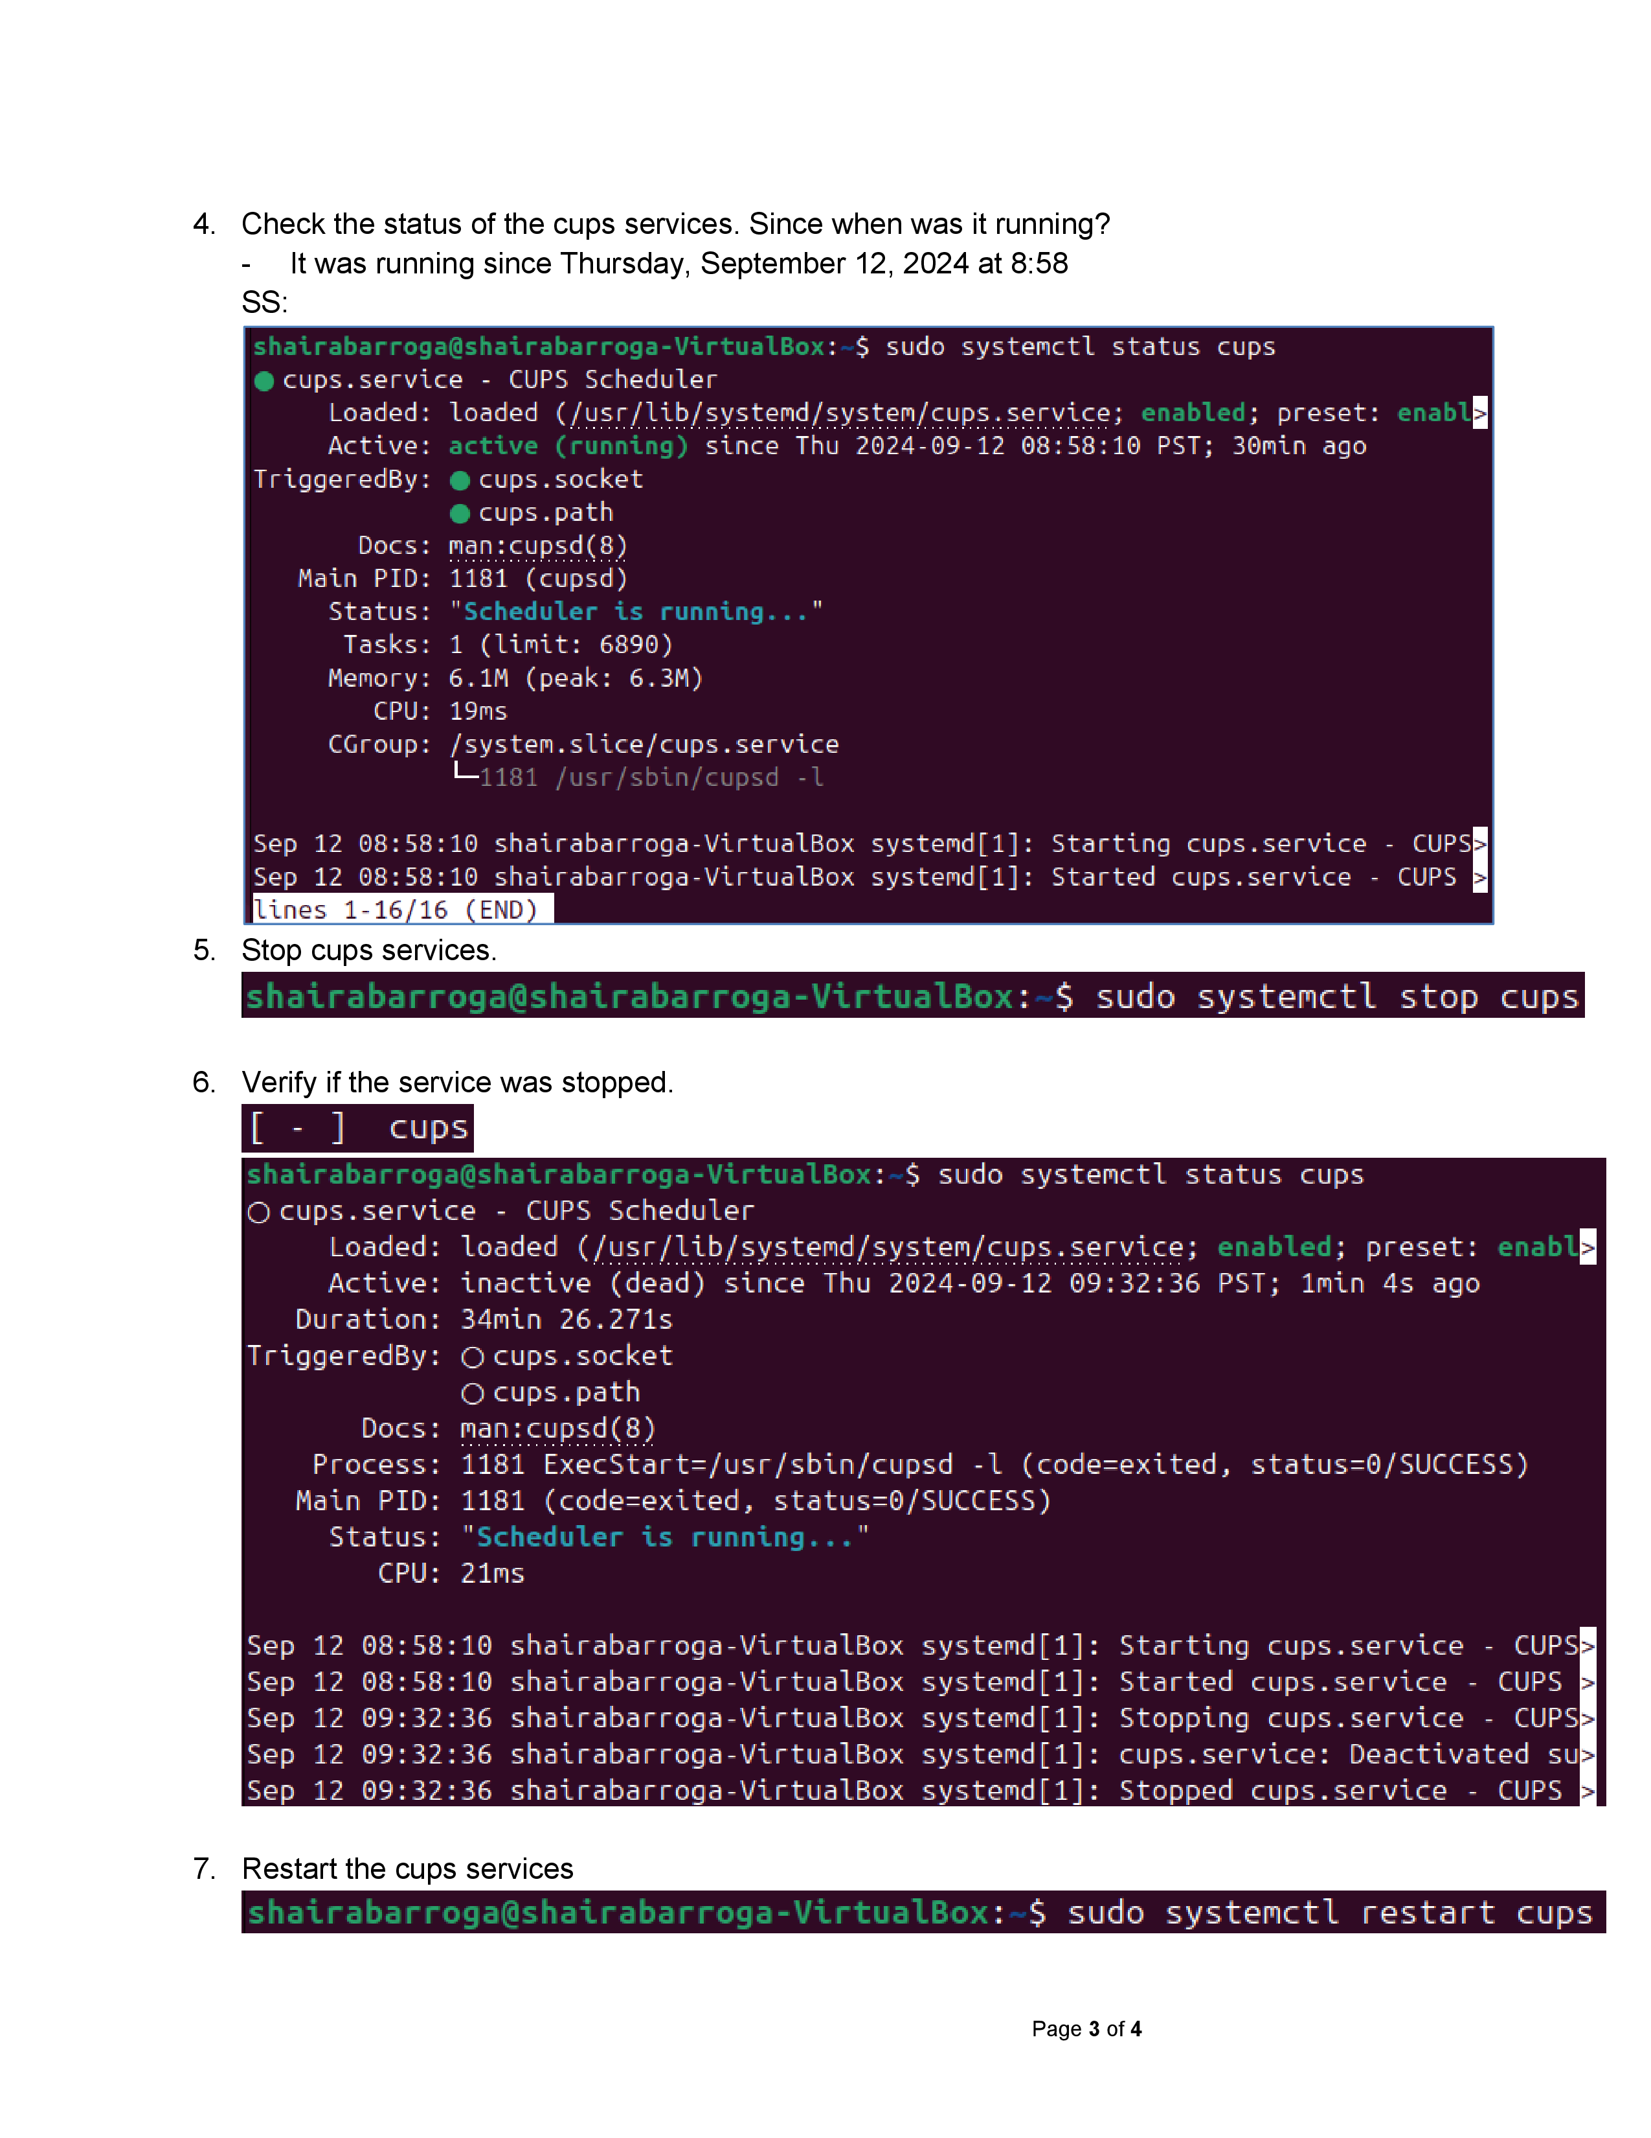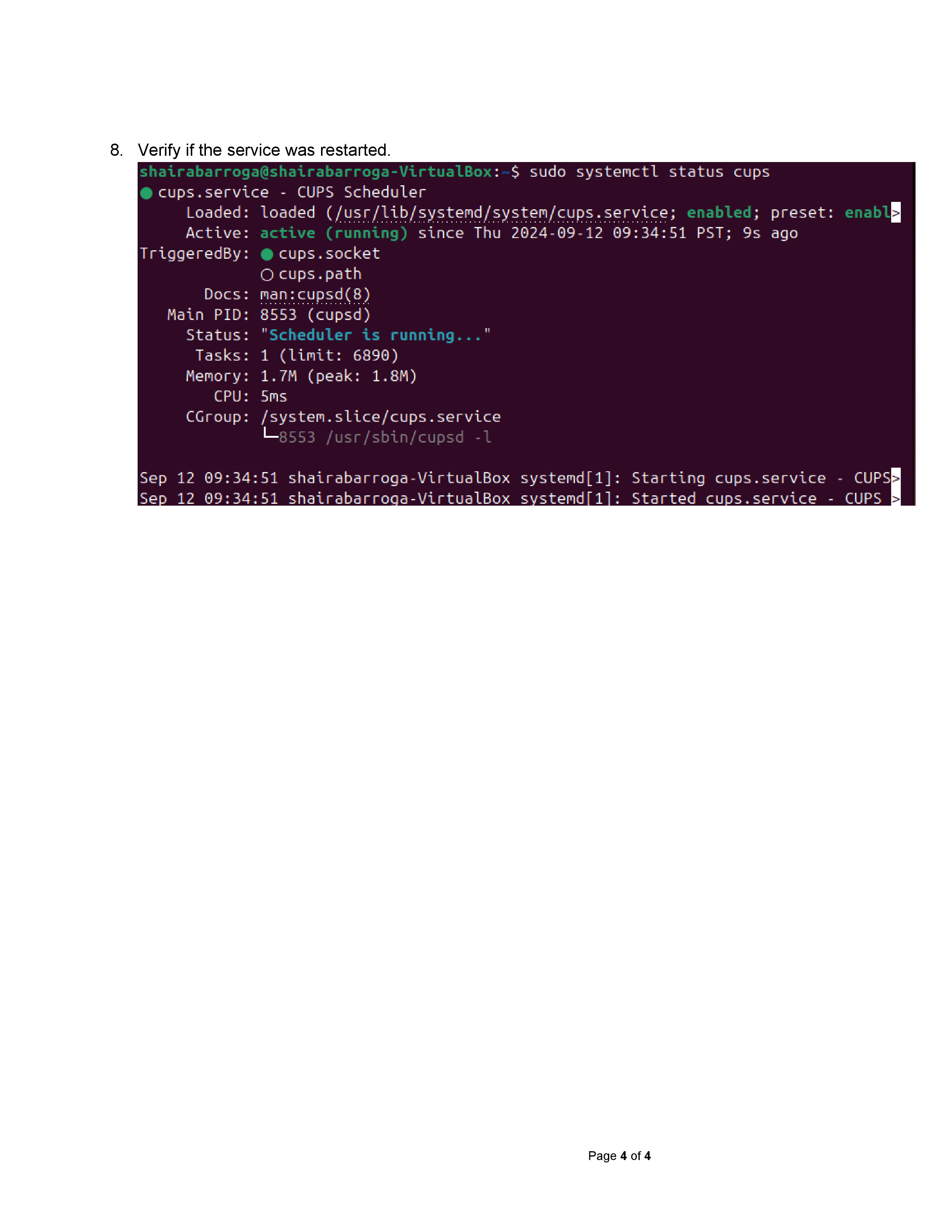

**Midterms**

**Activity 1**



**Server**

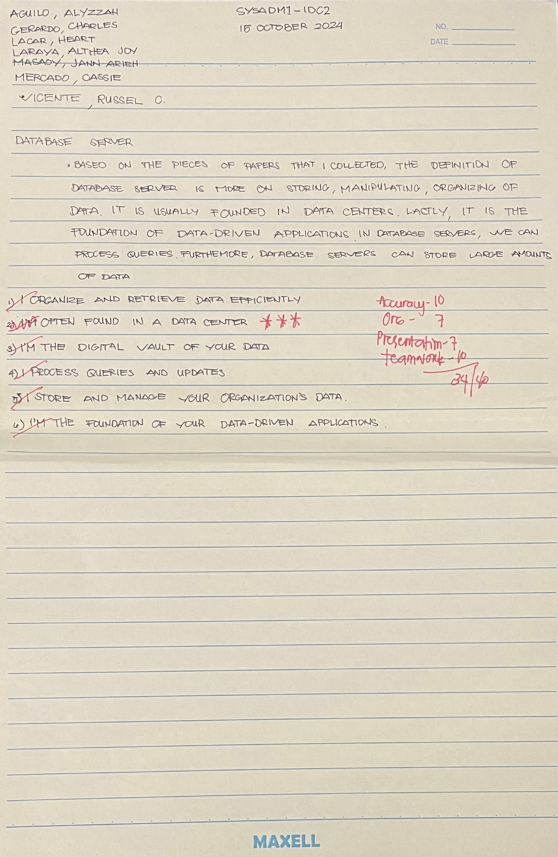

**Activity 2**

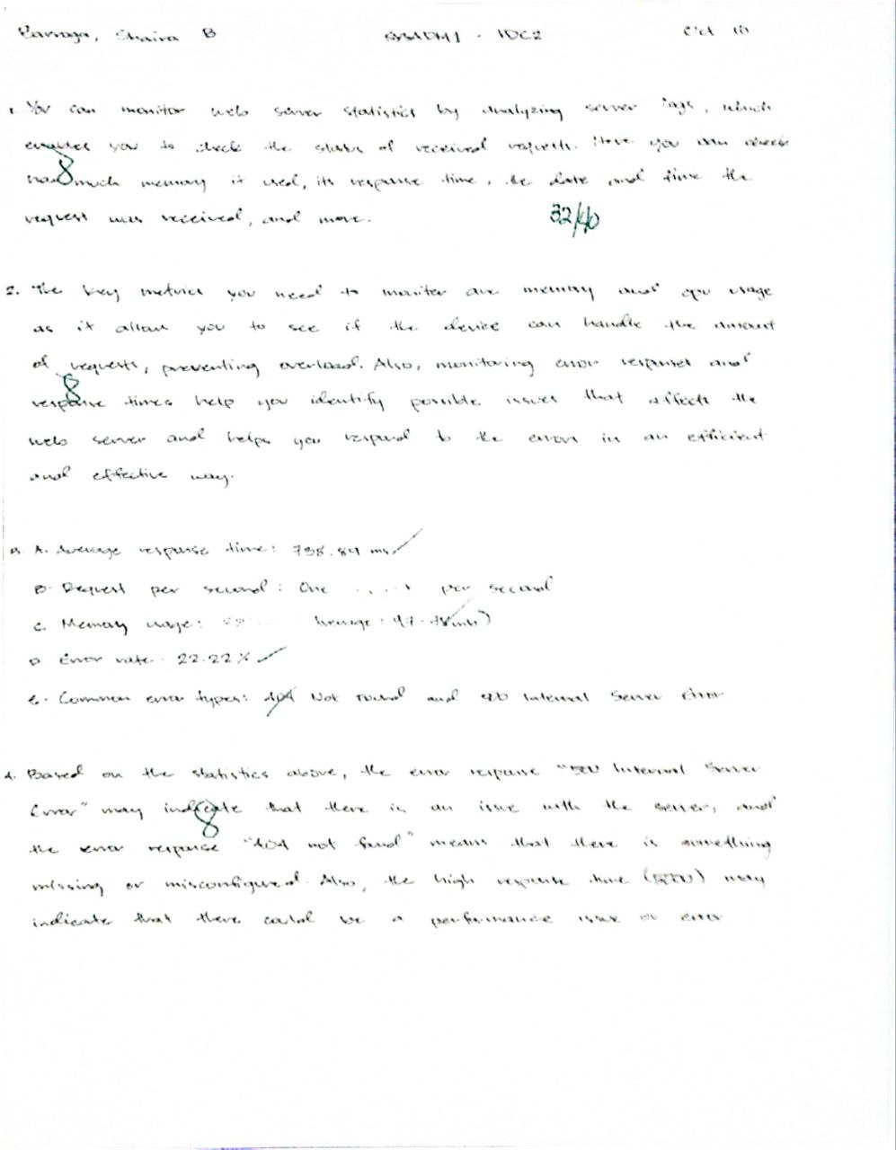

**Finals**

**Git**





**Data Loss**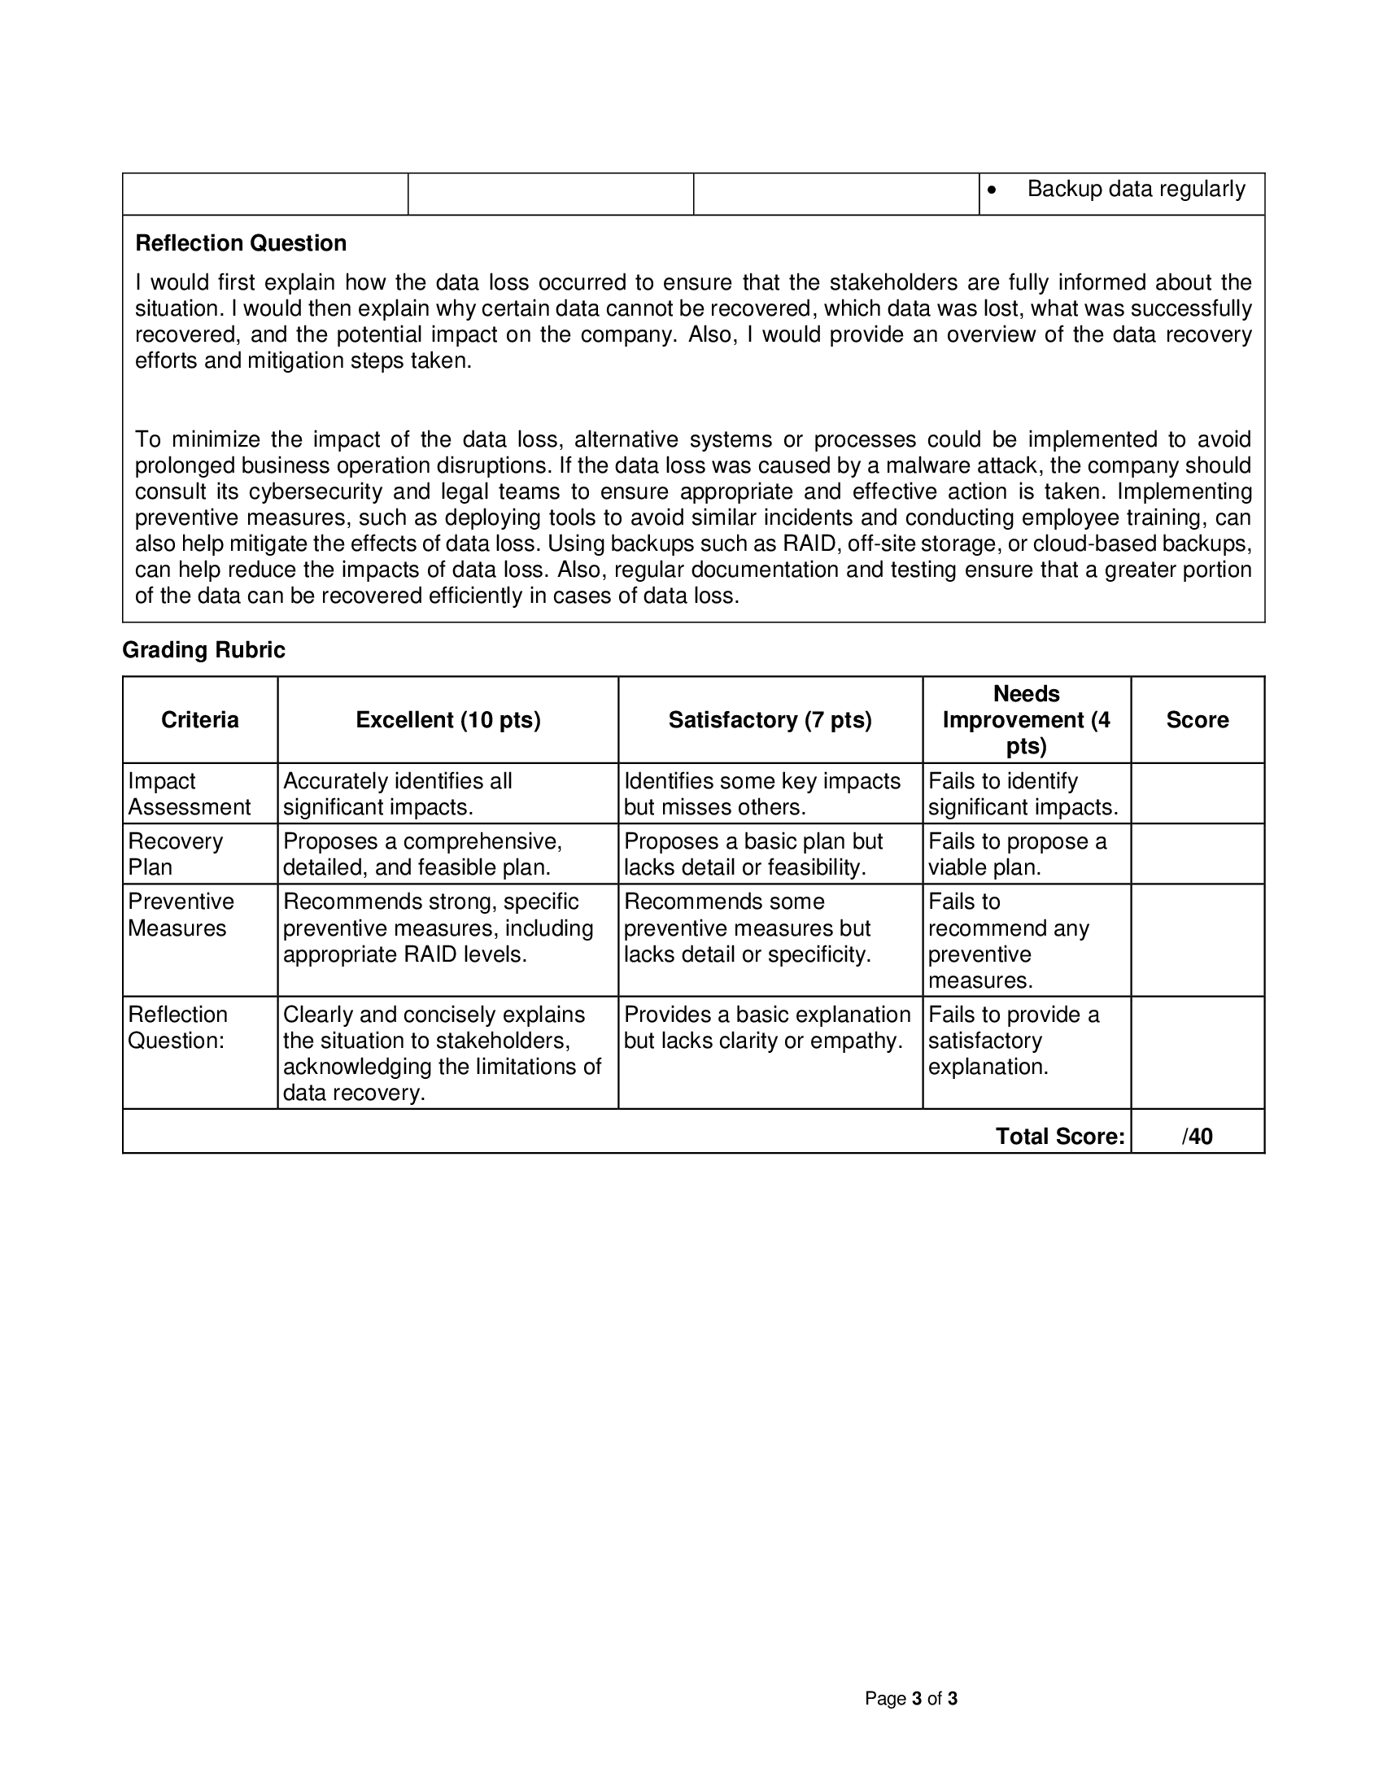

**Capacity Management & Planning**



**Course Reflection**

What were your initial expectations for the course? Did the course meet, exceed, or fall short of these expectations?

|  |
| --- |
| I expected this course to be a continuation of our previous subject, SERADM, and have similar activities. The course exceeded my expectations since, while some activities were similar, we focused more on management and learned new topics. |

What were the main topics or concepts covered in the course? How did these topics contribute to your understanding of the subject matter?

|  |
| --- |
| The main topics were learning to use Linux (using commands), understanding EULA, and using Git commands. These topics enhanced my understanding by providing hands-on experience to practice. |

Reflecting on your learning process, what were the most effective strategies or techniques that helped you grasp and retain the course material?

|  |
| --- |
| Repetition was the most effective strategy for me. Practicing repeatedly helped me retain the course material better. |

Were there any particular assignments, projects, or activities that significantly enhanced your learning experience? Why were they effective?

|  |
| --- |
| Creating policies and learning about EULA enhanced my learning. These activities were effective because they required attention to detail, which shows the importance of clarity in documentation. |

Did you encounter any challenges or difficulties during the course? How did you overcome these obstacles, and what did you learn from them?

|  |
| --- |
| Creating policies was difficult for me because I had to make sure they were detailed and covered all necessary aspects. Missing key features (e.g. addressing policy violations) could lead to issues. To overcome this, I organized and planned before writing the policies, imagined myself as the user, and considered the company's perspective. This taught me the importance of being thorough in problem-solving. |

Did the course encourage critical thinking and analysis? How did it promote higher-order thinking skills, such as problem-solving or decision-making?

|  |
| --- |
| Yes, the course encouraged critical thinking. When managing, I needed to interpret things like response time and CPU utilization to identify potential issues. Also, creating EULA required analyzing how it affects both the user and the company. |

Reflecting on your personal growth, what new knowledge, skills, or perspectives did you gain from this course?

|  |
| --- |
| I learned to be more observant when managing, organized when planning, and thorough when creating solutions or policies. These skills have improved my ability to analyze and address scenarios effectively. |

How do you plan to apply what you have learned in this course to your future studies, career, or personal life?

|  |
| --- |
| I can use these skills to create detailed documentation where I explain observations, propose solutions, and explain why they are necessary. These skills can be used in various fields and not just in the IT field. |